FREQUENTLY ASKED QUESTIONS
What if my prerequisites are not shown in STEMS?
Do you have your certificates on your computer/file?
Yes – You can upload your own certificates by logging into system and going to your profile. You can then select the “Request Course Credit” button. This is where you insert your certificate. You must upload one certificate at a time in a PDF form. IMPORTANT: You must upload EACH certificate individually for each class since they are different courses.
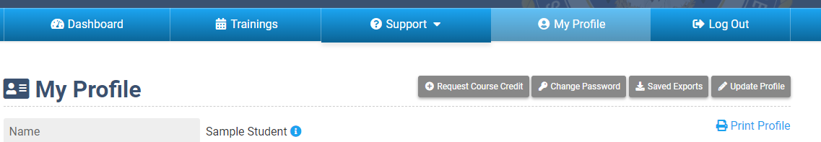
No - You can request your transcript through FEMA online. They usually respond very quickly. Once you receive your transcript from FEMA, please upload that transcript for each course. Each course if different, so that is why you need to upload a certificate for each course.

How do I get copies of my certificates?
You can login into the website and go to your profile and look at your history. You will then see a blue “wheel” image that you can click on and view your certificate, if available. If your data was transferred over from the old system, there is a likely chance that the image is not available, but your online transcript will suffice with dates. If you have received your certificate recently, there is a good chance that you will be able to view your certificate and you will see that it will say “view certificate” and that is what you will click. 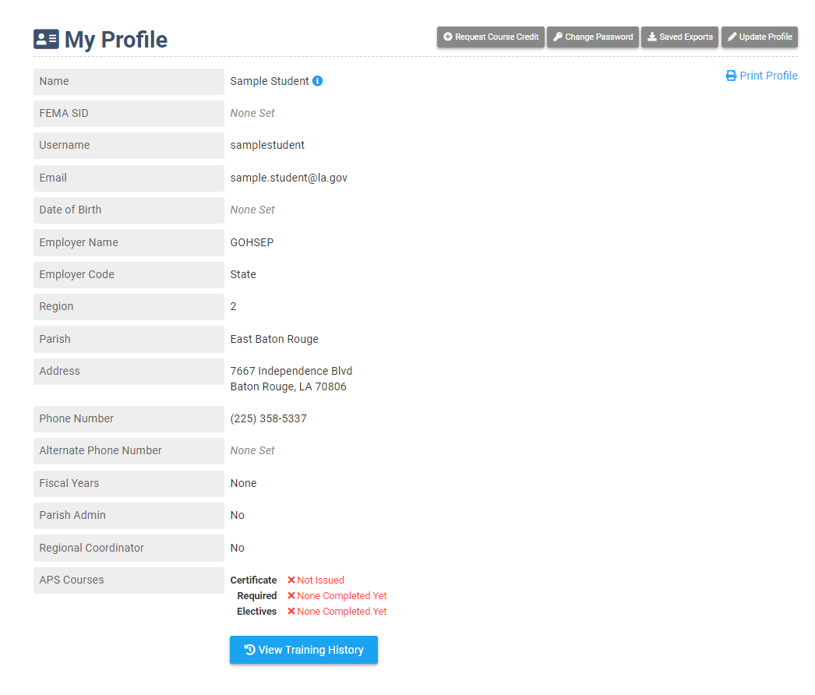
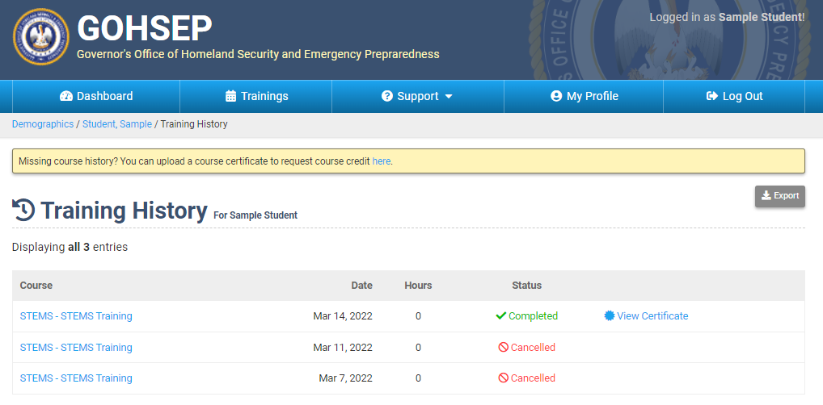

What if I get messages when I login at first and it tells me I need approval?
That is okay. It is indicating that you possibly have multiple logins that need to be merged. It does automatically send to GOHSEP for approval. Once you are approved and accounts are merged, you will be able to register for courses. You do not need to send an email to let us know you are waiting for approval, this sends automatically and will be taken care of within normal business hours.

What if I get a message that I’m not a user in the system?
You will need to re-register as a new user and it automatically sends to GOHSEP for approval. Once you are approved, you will be able to register for courses. You do not need to send an email to let us know you are waiting for approval, this sends automatically and will be taken care of within normal business hours. 